* **Deep learning** automates the feature engineering process, the complex task of representing the data which makes them special. The long pipelines of transformation are replaced by layers. These layers help in representation of data. These layers are updated simultaneously making DL special.
* **Tensors** are multidimensional numpy arrays. Number of axes in a tensor is called its rank.
* Scalars are **0Dtensors**, with rank 0. Array of numbers is a vector or **1D tensor**. Matrix is a **2D tensor**. Array of matrices is a **3D tensor.**
* **Examples: *Vector data*** i.e. (samples, features) is 2D tensor. ***Timeseries data*** i.e. (samples, timesteps, features) is a 3D tensor, ***Image data*** i.e. (Samples, height (i.e. no of pixels vertically), width, channel/color depth) is a 4D tensor, ***video data*** i.e. (Samples, frames, height, width, channel)
* **Shape** is the tuple of integers describing the number of dimensions along each axis. 0th axis is the sample axis denoting the sample number.
* **Pytorch (fb)** & **Tensorflow(google)** are frameworks in DL. Keras is wrapper or tool to work with Tensor flow easily
* A single layer of neuron which adds all the inputs and uses an activation function to determine the output is a perceptron.
* It can work well for the linearly separable class
* **Softplus: log (1 + exp(x) ) , RelU: Rectified Linear function max(0,x)** are common activation functions along with Sigmoid: (1/(1+e^(-x))).
* **Embedding layer:** Embedding layer helps in applying one hot encoding with dimensionality reduction on text data, called as word embedding. It requires 3 inputs input dimension i.e. size of vocabulary or no of unique words, output dimension i.e. length of output vector for each word, input length : max length of sequence.

<https://medium.com/analytics-vidhya/understanding-embedding-layer-in-keras-bbe3ff1327ce#:~:text=Embedding%20layer%20is%20one%20of,word%20embeddings%20such%20as%20GloVe>.

* **Vanishing gradient problem with sigmoid and tanh:** Gradient decreases as x increases thus, learning becomes very slow.
* **For hidden layers:** use RELU function or leaky relu as it is computationally very less expensive. However if initialisation is less than 0 then weight of that neuron is never updated and thus we use leaky relu
* **Symmetry problem:**  We have same updates thus same neurons all over. W
* **Backpropagation NN**: It is an algorithm used to determine the optimal weights. Loss function is written in terms of all the weights, input and output and gradient descent wrt to each parameter to be optimised is used.
* **Arg max, Soft max:** When we have multiple inputs and outputs the output values can be > 1 or < 0. Here, we use argmax to limit these values. Argmax converts max to 1 and others to 0. As Argmax is not differentiable, we use softmax for training and argmax for output. We use cross entropy as output is the predicted probability.
* **CNN:** 1. Reduces no of input nodes. 2. Takes the advantage of correlation i.e white space is near the white space 3. Tolerates shift in pixels. Values of different pixels of a filter is initially 0 and further it is modified after training. Dot product of input with filter is feature map. Each cell in the feature map corresponds to a group of neighbouring pixels and thus uses correlation. Typically, **RelU** activation is applied to feature maps. Then, **Max pooling** is applied. It is a filter which does not overlap and selects the max value. **Avg pooling**  is also done.
* Sigmoid function is for Binary class and softmax is for multilass
* Sequence models are **the machine learning models that input or output sequences of data**. Sequential data includes text streams, audio clips, video clips, time-series data, etc. Recurrent Neural Networks (RNNs) is a popular algorithm used in sequence models. ... Here both the input and output are sequences of data.
* Simple models cannot be used in NLP because length of output may change. Also, high computations are required for converting to vectors. Same probl;em of CNN i.e. parameters are not shared.
* **Dropout** is a method of dropping the randomly selected neurons from the net.
* **Padding:** Using CNN the pixels at the boundaries don't get used well so we use padding to avoid the number of times they are multiplied with a filter. Also for text to give input of equal length, we use padding.

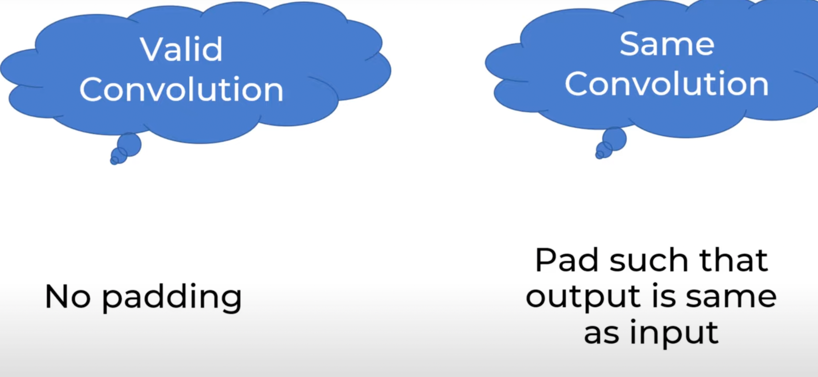

* **Stride:** Distance travelled by convolution filter

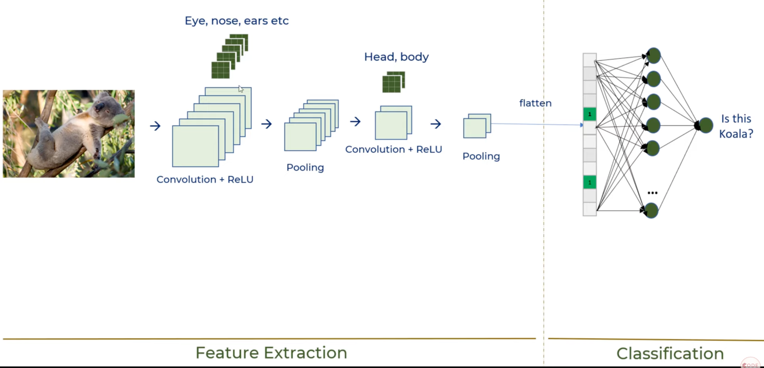

Categorical encoding is used when the target column is one hot encoded. And when it is a direct value, we use sparse categorical encoding.

**RNN:** It takes the output of the previous input as a new output as well. Sequential nets don’t have a memory in RNN output for one data point as an input for another.

**Types of RNN:** One to many (Input vector has a single time step, output vector has multiple time steps)**,** Many to many, Many to one.

RNN should ideally consider the effect of all the previous entries for any given time, but due to vanishing gradients it does not remember information in previous time steps in long series. Vanishing gradient problem also occurs in normal dense RNN when the number of layers are large.

**LSTM MODELS:**

LSTM carries a important states in memory and doesn’t let the network forget that.

[**https://machinelearningmastery.com/how-to-develop-lstm-models-for-time-series-forecasting/**](https://machinelearningmastery.com/how-to-develop-lstm-models-for-time-series-forecasting/)

1. Univariate LSTM: Series of data is given and next entries are to be found.
2. Prepare the data: Create multiple input output data / Samples.
3. **Vanilla LSTM**: Single LSTM layer and an O/P layer

**LSTM exploding gradients:**

* Large updates of weights can lead to exploding gradients.
* Changing the derivative of error before propagating it backwards is a solution.
* Rescaling the gradient and clipping it are options.
* In CNN or MLP the underflow or overflow can occur due to

1. Incorrect Learning rate.
2. Improper data prep, large difference in target variable
3. Improper loss function.

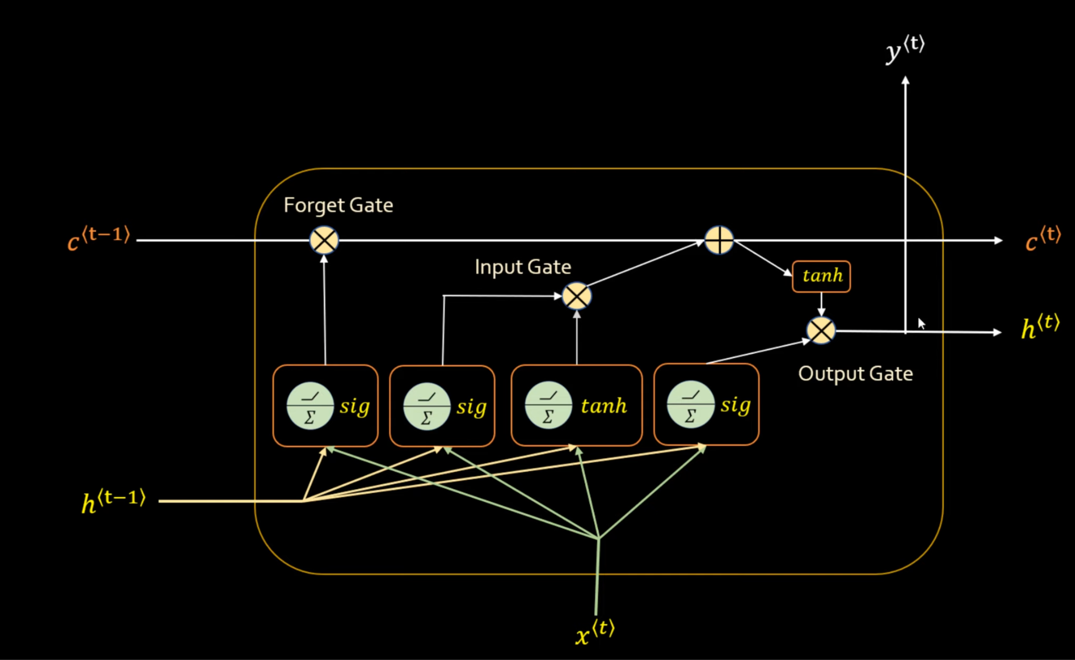LSTM

There are weights on each arrow oc, which are trained.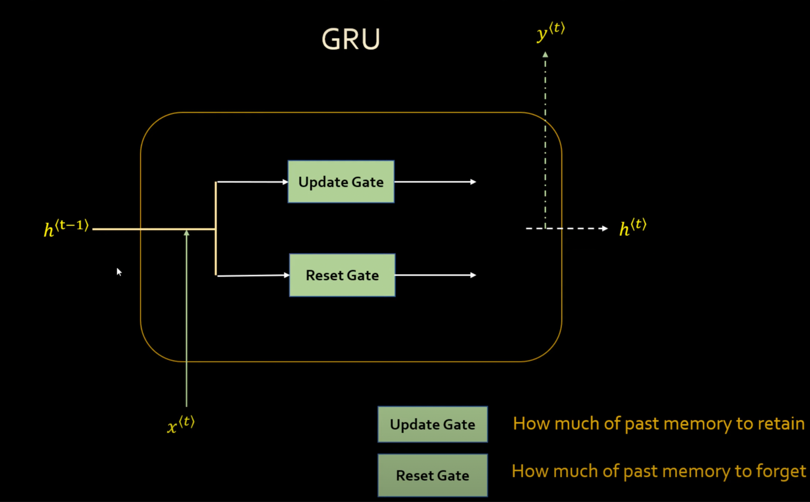

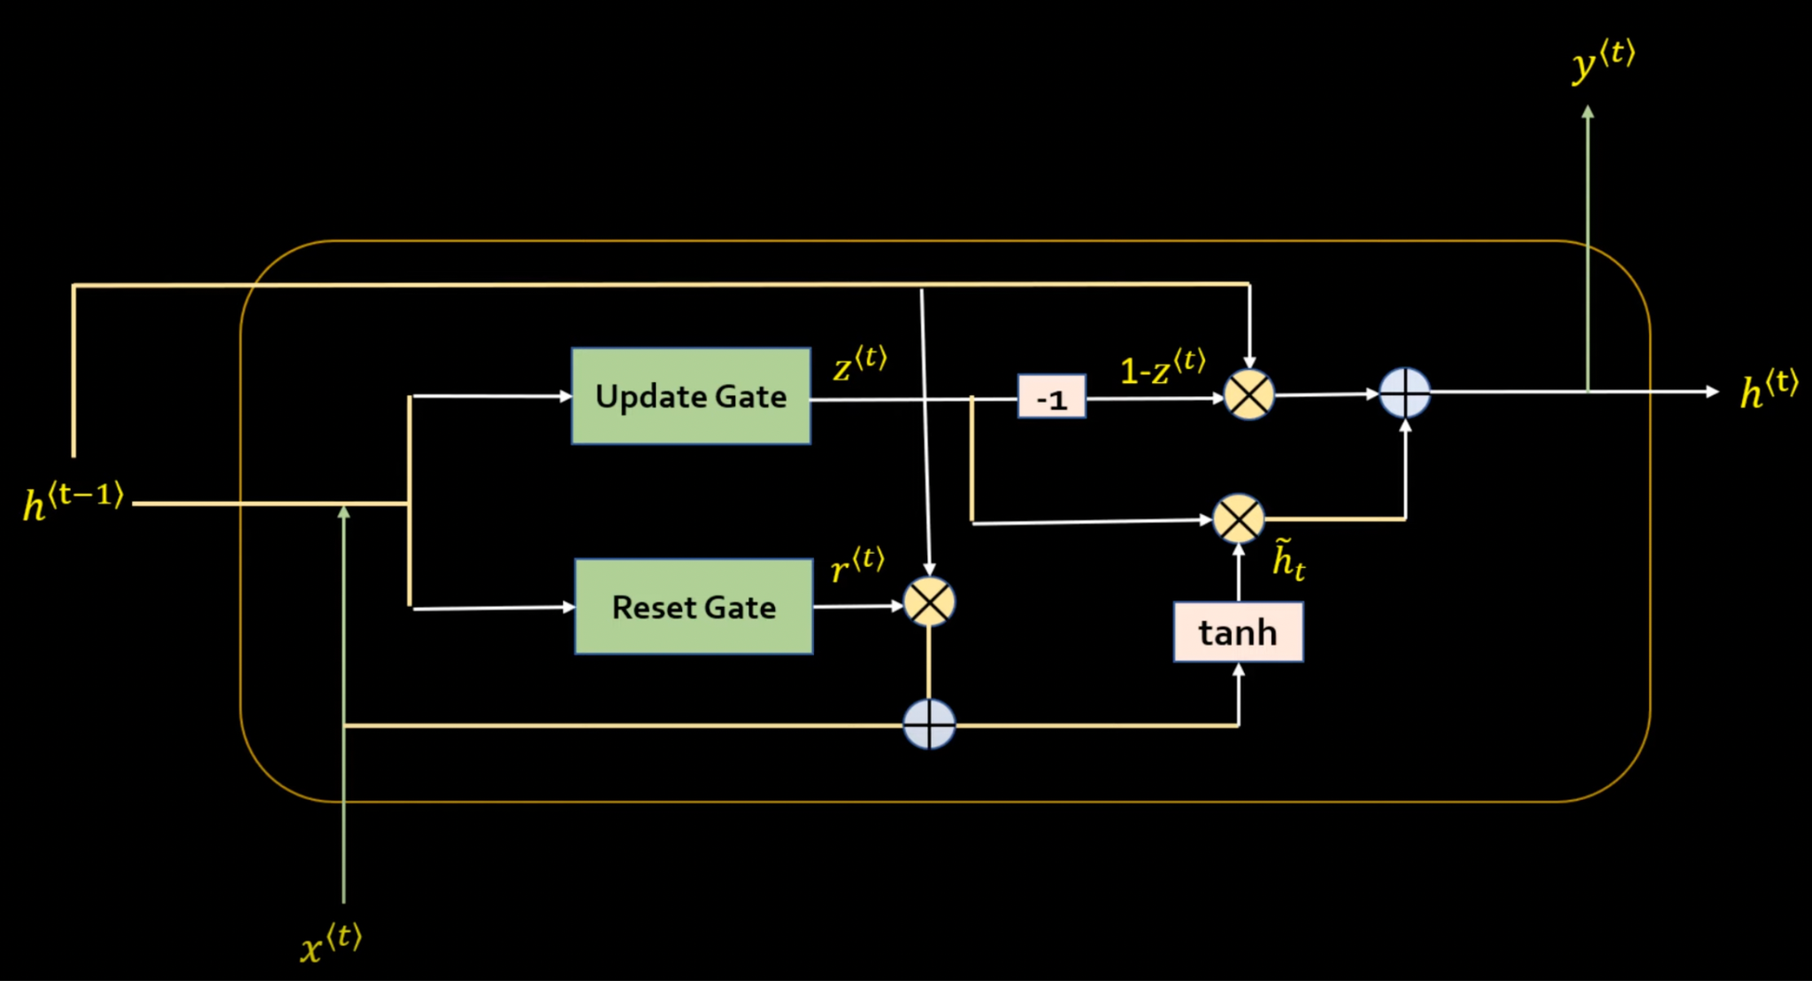

**GRU:**

GRU are lighter version of LSTMs. It combines long and short term memory into hidden box

**JUST REMEMBER THAT LSTM HAS 3 GATES AND GRU HAS 2. GRU IS COMPUTATIONALLY EFFICIENT AND FAST.**

Deep learning requires 2 types of tuning:

1. Hyperparammeters
2. Number of layers

**Hyperparameter tuning for Deep Learning:**

<https://www.analyticsvidhya.com/blog/2021/05/tuning-the-hyperparameters-and-layers-of-neural-network-deep-learning/>

**Optimizers in Deep learning:**

Optimisers are algorithms used to update the parameters such as weight, learning rate in DL. These parameters and weights are updated to minimise the loss function.

<https://towardsdatascience.com/optimizers-for-training-neural-network-59450d71caf6>

<https://www.youtube.com/watch?v=TudQZtgpoHk>

[**https://www.analyticsvidhya.com/blog/2021/10/a-comprehensive-guide-on-deep-learning-optimizers/**](https://www.analyticsvidhya.com/blog/2021/10/a-comprehensive-guide-on-deep-learning-optimizers/)

1. Gradient descent and its variants:
   1. **Vanilla gradient descent:** Simple gradient descent that iterates over whole data which makes it expensive
   2. **Stochastic gradient descent:** Takes random samples at any iteration to calculate gradient and then updates the weights. So if weights are updated with each data point, there is a lot of variation in weights.
   3. **Momentum gradient descent**: Remembers previous gradients to accelerate convergence. As stochastic gradient is noisy, it adds a fraction of weight update from previous iteration which results in faster convergence. Technically, it considers the exponential weighted average

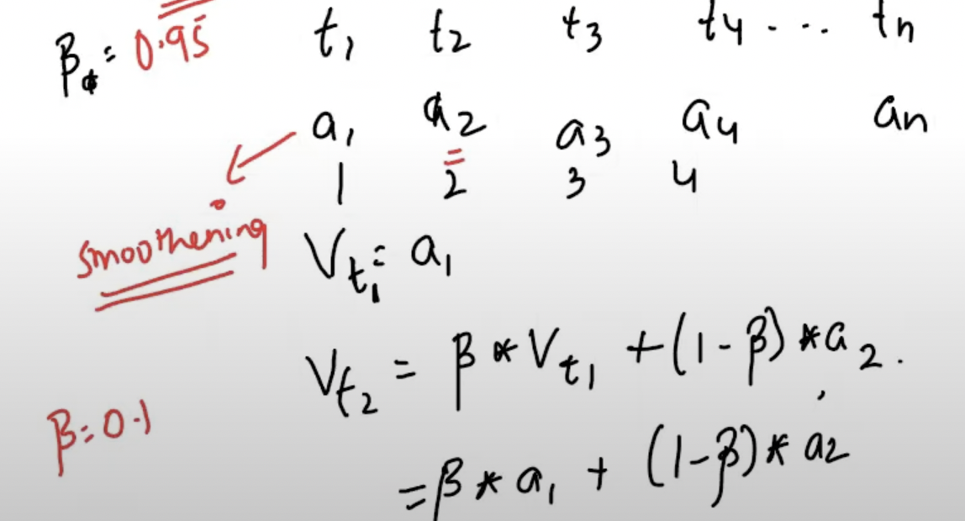

For any data with t1, t2, t3 ,... being the timesteps and a1, a2, a3, a4 .. be the datapoints and beta being a parameter signifying the importance of previous data point, **Vt2 is the exponential weighted average** of current and previous data point.

* 1. **Accelerated gradient descent:** Momentum gradient considers the gradient from previous iteration and if it has high value, we may miss the minimum. So what we do in accelerated gradient is we track the future value and reduce the momentum.
  2. **Batch gradient descent algorithm:** It uses a batch or subset of data to calculate the loss function and thus converges quicker as compared to vanilla and stochastic gradient.
  3. **Adaptive gradient descent (Adagrad)**: Takes varying step size or learning rate for each iteration. Learning rate depends on the change in weight. If higher is the change, smaller is the learning rate. It is a second order derivative descent method i.e. uses the derivative of the error function. Learning rate is decaying as it accumulates all the previous gradients. When we have a very deep network, alpha becomes huge and learning rate is very small i.e. network is not learning.

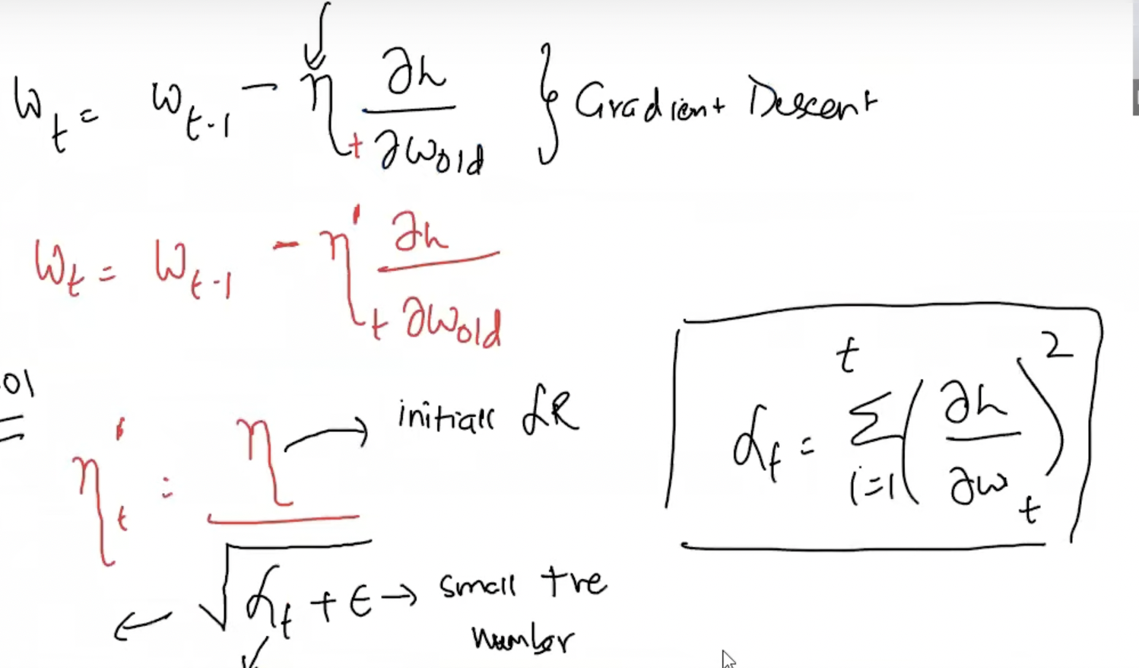

* 1. **AdaDelta or RMS prop:** Extension of Adagrad, it only accumulates small amount of window for previous gradients or other method is like below. **Beta is usually 0.9 here.** We don’t allow denominator to grow very large.

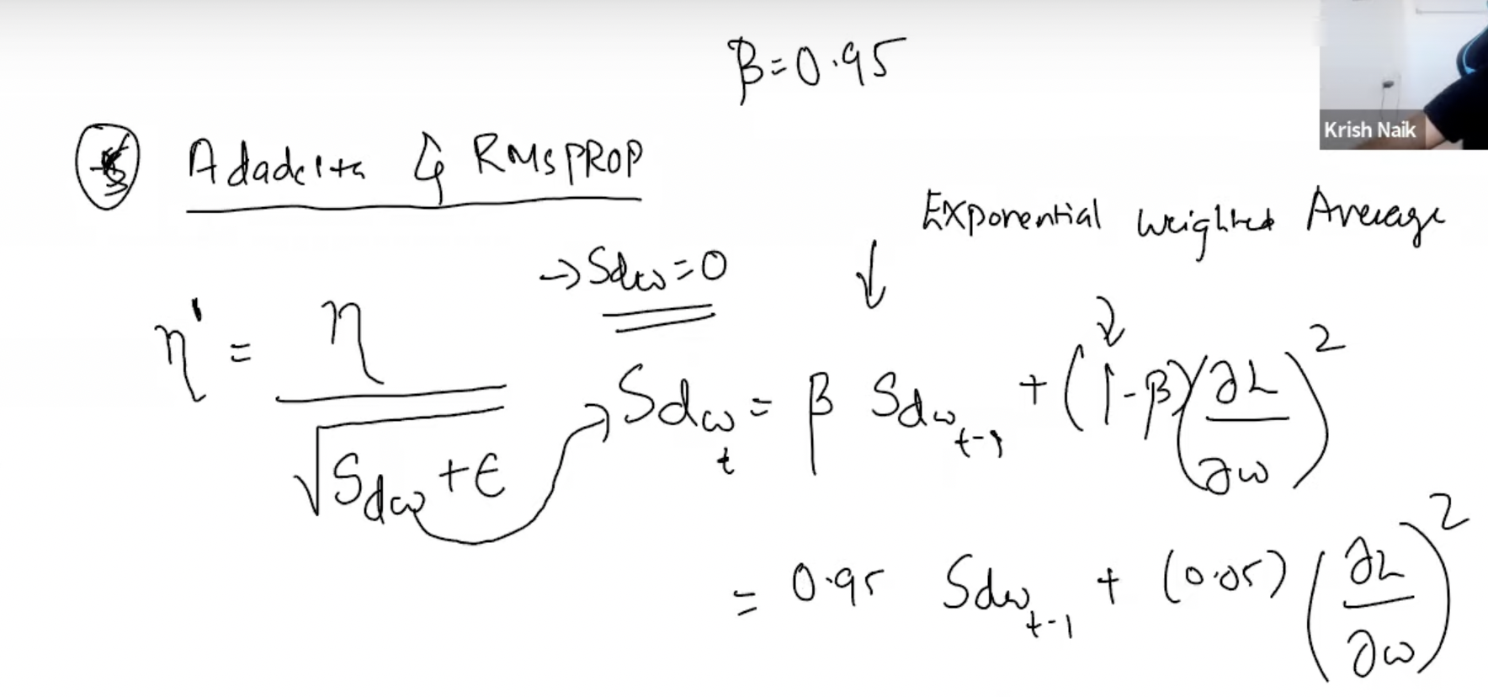

* 1. **Adam (Adaptive momentum estimation):** Works with momentum of first and second order.

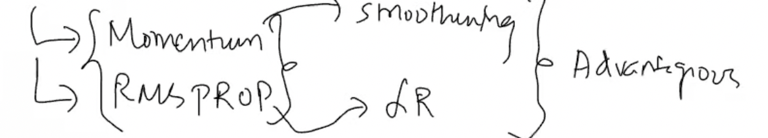

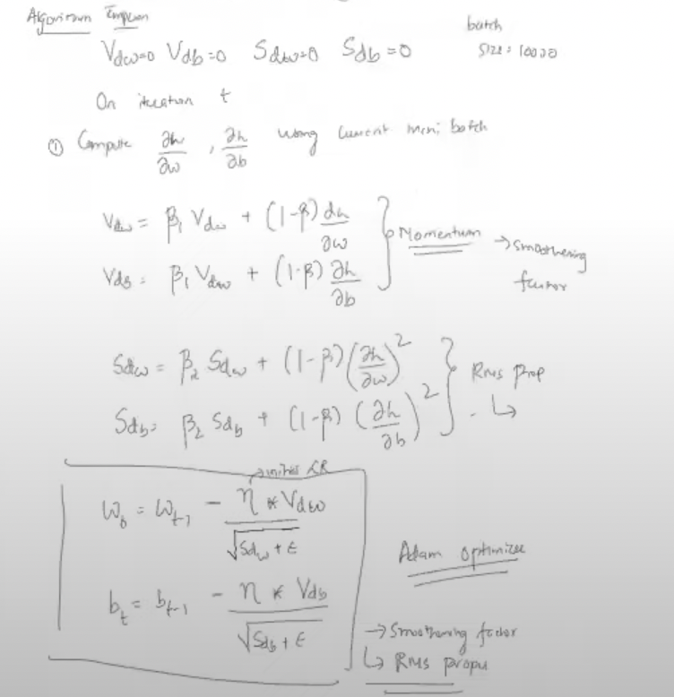

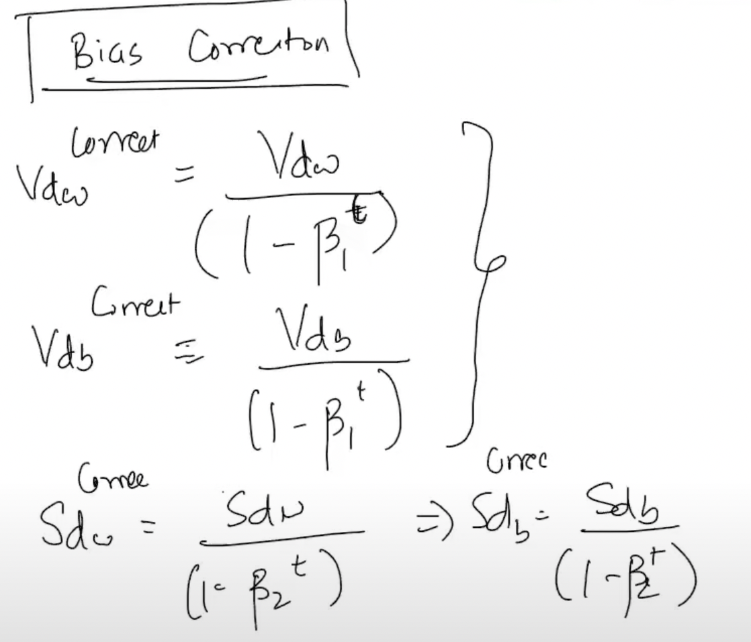

**LOSS Function:**

When error is calculated for a single record, method is **loss function** and when error is calculated for a batch, method is called as **cost function**.

**Loss function in regression:**

1. **Squared error loss:**

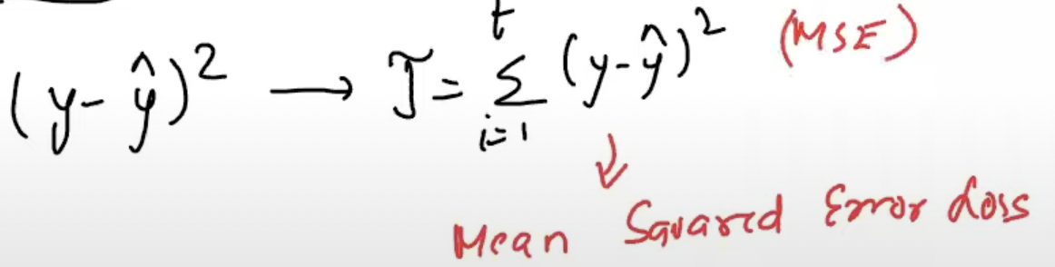

Advantages:

1. It is quadratic equation hence, will always have roots and a global minima and no local minima.
2. Penalise the large errors by squaring them

Disadvantages:

1. Not robust with respect to outliers
2. **Mean absolute error:**

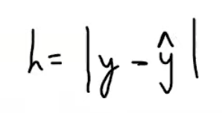

Advantages:

1. Robust to outliers

Disadvantages:

1. Computation is expensive, not differentiable at yhat
2. **Huber loss:**

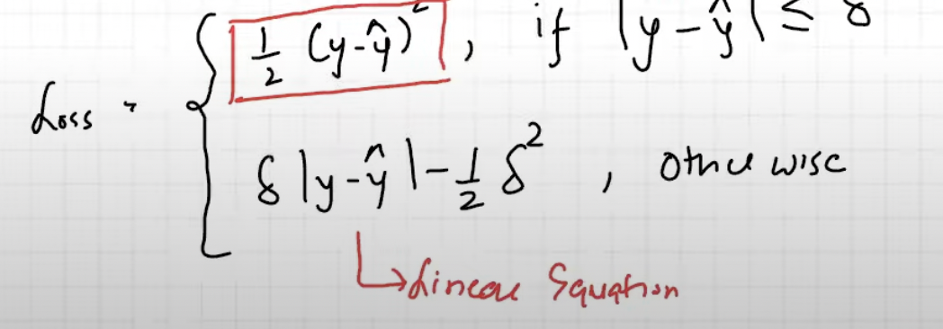

It combines MSE and MAE. Delta is a hyper parameter. There is a outlier, |y-yhat| > Delta and we consider MAE so that outlier is not squared. Else, MSE a quadratic loss function is considered.

1. **Cross Entropy:**

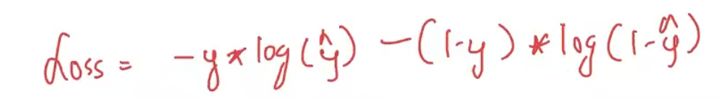

This is Binary cross entropy and used for Binary classification problem.

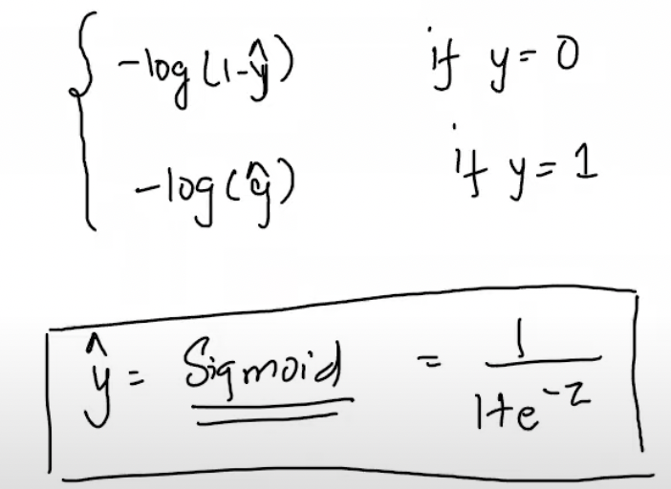It gives these 2 values depending on y.

Here, y is the actual output and yhat is the predicted probability

1. **Multiclass cross entropy loss:**

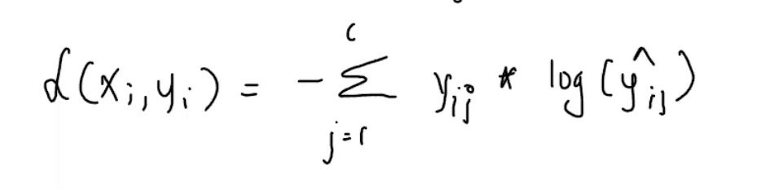

C is the number of classes and i is the ith data point.

1. **Sparse categorical class entropy gives the index of class with highest probability.**

**Activation functions:**